**Technical analysis library python API installation**

1. Open the command prompt and run the following command

pip install talib

1. If the previous command does not throw any error, you are one of the luckiest persons on this planet. Verify that the installation is proper by running the following command in Ipython console of Spyder IDE.

import talib as ta

help(ta)

If installation is successful the previous command should list the documentation. If installation is not successful and you get the following error, go to step 3

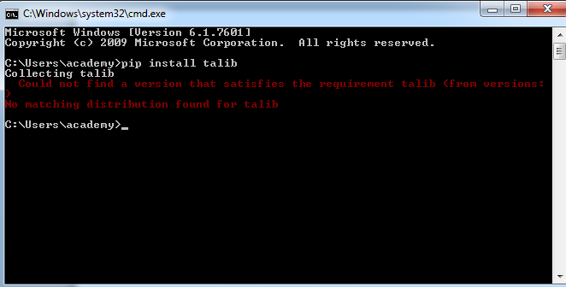

1. Go to the following url and scroll down to the ta-lib heading

<http://www.lfd.uci.edu/~gohlke/pythonlibs/>

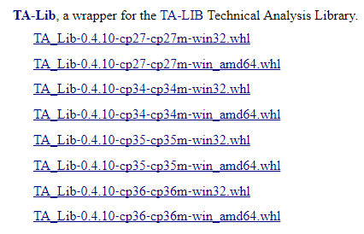

1. If you are using Spyder 2.7 and system is 32 bit download the first file. If you are using Spyder 2.7 and your system is 64 bit download second file by clicking on it.

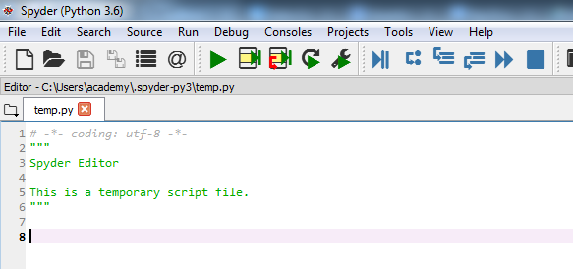

As you can see my Spyder has Python 3.6 and the system is 64 bit, so I download the following file

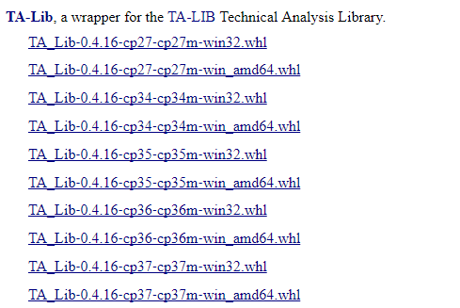

1. Paste the downloaded file in C drive and run the following command in the command prompt

pip install TA_Lib-0.4.16-cp36-cp36m-win_amd64.whl

Upon running the previous command, you should see the following screenshot.

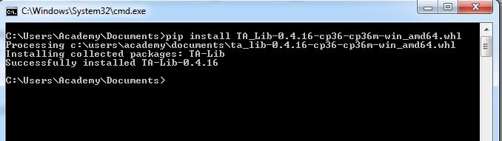

Go back to Spyder IDE and run the following command:-

import talib as ta

You should see the following output

